12th. Annual
PA Cruisers
Car and Truck Show
Memorial Day
Monday, May 25, 2026
Rain or Shine
Held at the Upton Community Center
Behind Stickell’s Old Store  5489 Buchanan Tr. W. Greencastle PA 17225
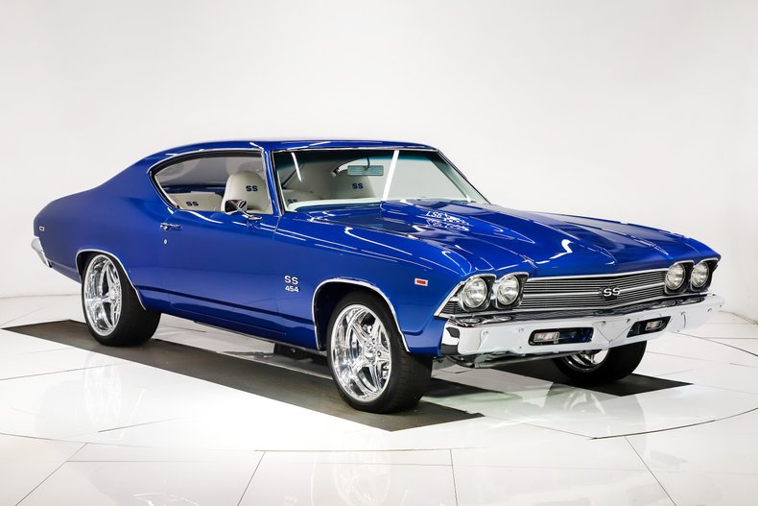
Registration: 8:00 AM to 12:00 Noon
Trophies will be awarded at 2:45 PM

$15.00 Entry Fee ~ 100 Dash Plaques
Trophies – Top 50 Cars, Top 10 Trucks, Top 5 Jeeps (24” Double Post Trophies)
Best of Show Car & Truck & Jeep (48” Tall Trophies)
10 Special Trophies
50/50 Raffle and Chinese Auction
Food on site: Boy Scout Troop 95, Shade Grove, PA
Not Responsible for Accidents on the day of Show
Contacts: Brian Mowen (717) 261-6019 and/or Ruth Knable (717) 597-7006
Please leave a message for a return call for information
If calling for extreme weather the date of show, we reserve the right to reschedule.

