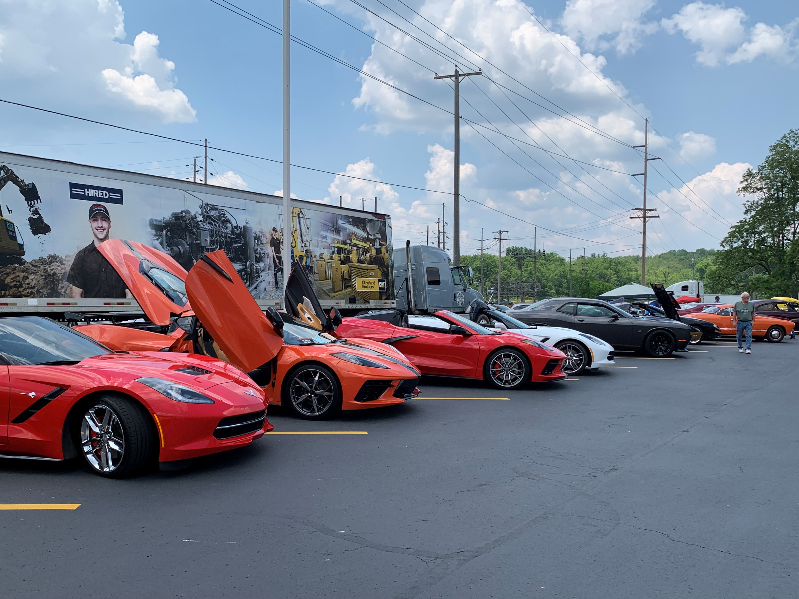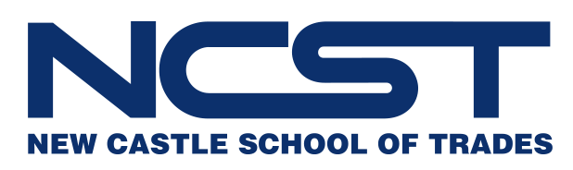

Spectators Free!

**For Car Show Registration please scan the QR code. The first 200 people to register for Car Show receive a Dash Plaque.**

New Castle School of Trades

7th Annual Car & Craft Show

**4117 Pulaski Rd.**

**New Castle, PA 16101**

**Car Show Registration Fee: $5.00**

**For more info contact:**

**Bill Grandy: 724-977-3541**

**Phil Riggs: 724-290-3870**

**Proceeds from Car Show benefit American Legion Riders**

**June 1, 2024**

**Car Show 10am-2pm**

**Craft Show 8am-4pm**

**Gates open at 8am**