
6th Annual Car & Truck Show
Saturday – August 15, 2026
(Rain or Shine)
The Vigilant Activities Building
17701 Creamery Road
Emmitsburg, MD 21727

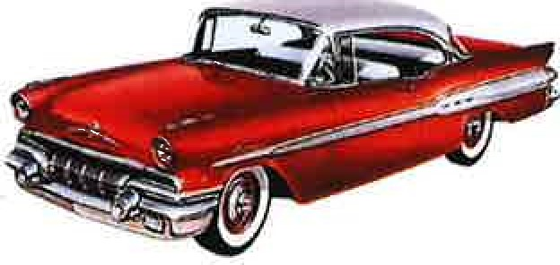
Registration: 8:00 AM to 11:00 AM Awards at 2:30 PM
$15.00 Entry Fee  Food by Vigilant Hose Co.
Trophies- Top 25 Cars & Top 10 Trucks (People's Choice)
Best of Show Car and Best of Show Truck (People's Choice)
Best overall Vehicle (Team WFRE Choice)
Childhood Cancer Survivor Choice

50/50 Door Prizes Silent Auction
More information: Contact Jean Eyler 240-409-2128 or Donnie Eyler 240-626-3535
Team WFRE and The Emmitsburg Ambulance Company (Vigilant Activities Building) will NOT be held responsible for any accidents or damage to any vehicles. Sponsored by; Jeep Fest for Charity Inc.

